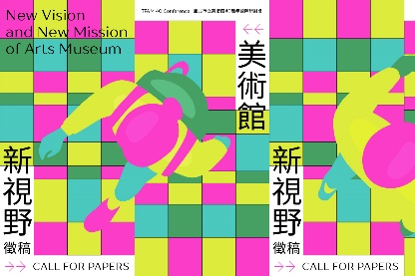
TFAM 40 Conference:
New Vision and New Mission of Arts Museum

4–6 October 2023
Taipei Fine Arts Museum, Taipei, Taiwan

Art museums shoulder the mission of preserving, researching, developing and popularizing art, serving society at large and strengthening public service. Yet recently countries around the world, especially the countries of Asia, face the immense challenge of population aging. Responding to the impact of population shifts and understanding the needs of visitors will be a means for art museums to develop sustainably. Furthermore, art museums are increasingly expected to play a role in urban development by driving the renewal of local districts, shaping cities’ images, and promoting local development and economic vitality. To celebrate the 40th anniversary of Taipei Fine Arts Museum (TFAM), this conference will address the challenges and opportunities of contemporary art museums, in order to buttress the missions and objectives of art museums.

We welcome proposals for presentations and other kinds of session that address the conference themes (see call for papers). Please complete the attached conference proposal form and submit to tfam40conf@gmail.com by 31 March 2023.

Enquiries may be sent to: tfam40conf@gmail.com
We will notify you of the outcome of your proposal by the end of April 2023.

We anticipate that selected papers will be published to accompany by the conference and authors will be asked to submit papers of between 3000 and 5000 words by 1 September 2023 by email to tfam40conf@gmail.com.

All proposals, presentations and papers must be in English or Chinese.

Important Dates
2023.03.31 | Deadline for Proposals Submission
2023.04.30 | Notification of Acceptance
2023.06.01 | Conference Agenda Announcement
2023.09.01 | Submission Deadline for the Final Version of the Proceeding Paper
2023.10.04-06 | TFAM 40 in Taipei, Taiwan

New Vision and New Mission of Arts Museum
Conference Proposal Form

Name of session proposer

Job title / role

Organisation

Email

Title of the paper

Key words (up to five)
Tell us about your presentation (500 words max)

Please submit this form to tfam40conf@gmail.com with the subject line “TFAM 40 Conference Proposal” by 31 March 2023.

